RANELAGH PRIMARY SCHOOL
Attendance Newsletter – WC 7.9.26-11.9.26
Paul's Road, Ipswich, Suffolk, IP2 0AN
Headteacher: Mrs O. Hopper
Tel: 01473 251608 email: admin@ranelagh.suffolk.sch.uk
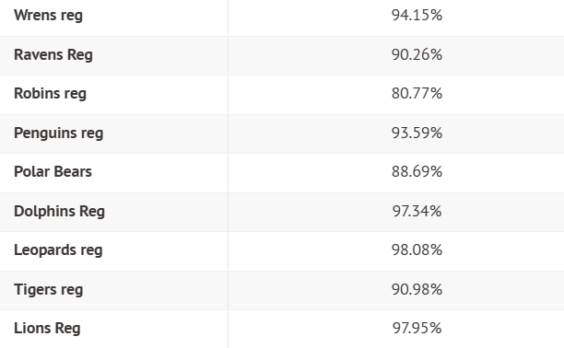
Welcome to the 14th edition of our attendance newsletter. Our school attendance target is 96% and the overall attendance so far this year is 94.55% (an increase of 5.03% since last week).

Please do reach out and speak to Miss Pearl or Mrs Hearn if we can help in any way regarding your child’s attendance and punctuality. This can be through emails to admin@ranelagh.suffolk.sch.uk and adding FAO Miss Pearl / Mrs Hearn.

Here is a breakdown of class attendance (children at statutory age only) from 3rd September until 11th September 2026.

Well done to the classes who have raised their attendance from last week:
Ravens | +11.61%
Robins | +5.18%
Penguins | +5.79%
Polar Bears | +7.03%
Dolphins | +1.71%
Leopards | +1.09%
Tigers | +8.55%
Lions | +1.85%

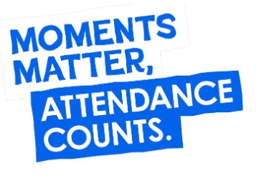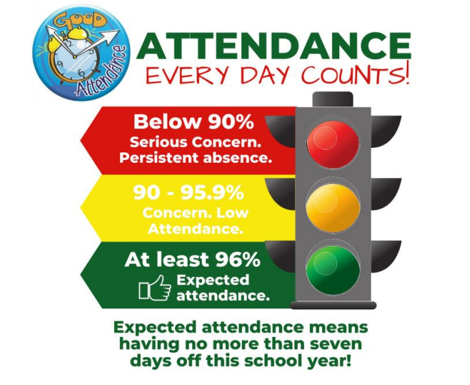

The winning classes for attendance 7th-11th 2026
EYFS/KS1 | 95.56% | 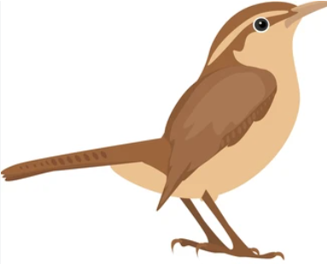
LOWER KS2 | 97.86% | 
UPPER KS2 | 98.52% | 

Useful Links
https://www.suffolk.gov.uk/children-families-and-learning/schools/school-meals-uniforms-and-trips/apply-for-free-school-meals You can apply online for free school meals. You'll get an immediate response and confirmation email after you've completed your application.

https://www.nhs.uk/every-mind-matters/supporting-others/childrens-mental-health/
